|  |
| --- |
| **Flipkart** |

**FUNCTIONAL REQUIREMENTS DOCUMENT**

**Product Name: Flipkart**

|  |
| --- |
|  |

Overview

The Flipkart Group is one of India’s leading digital commerce entities and includes group companies Flipkart, Myntra, and Jabong. Launched in 2007, Flipkart has enabled millions of consumers, sellers, merchants and small businesses to be a part of India’s e-commerce revolution. With a registered customer base of over 100 million, offering over 80 million products across 80+ categories, Flipkart is known for pioneering services such as Cash on Delivery, No Cost EMI and easy returns – customer-centric innovations that have made online shopping more accessible and affordable for millions of Indians. Together with Myntra and Jabong, which hold prominent positions in the online fashion market, the Flipkart Group has steered the transformation of commerce in India through technology.

Requirements

Flipkart requires certain technical requirements to be met for the store to operate properly. First, a web server must be created to make the Flipkart store publicly available on the web.

JavaScript, the language of the web, plays a pivotal role in enhancing the user experience on Flipkart's platform. Through frameworks like React. js, Flipkart leverages JavaScript to build dynamic and responsive user interfaces, ensuring an engaging and interactive shopping experience.

Flipkart Frontend

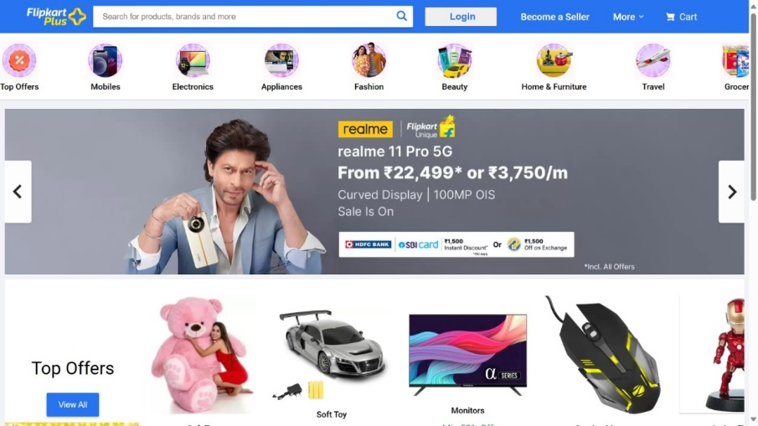This Document is intended to be used as an introduction to the Flipkart default store front. The store front reveals how the customer views and interacts with the store.

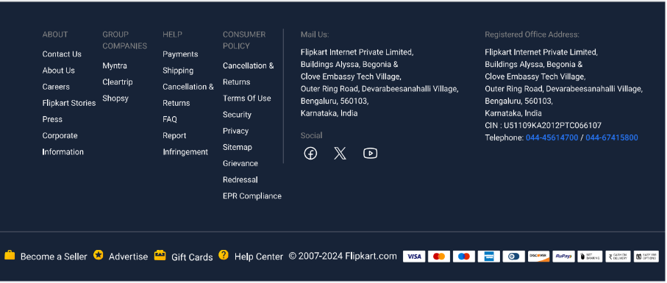

The products seen above are included as sample data.

Navigating the shop

The Flipkart default theme makes navigating a shop's products easily accessible to its customers.

Home page

The home page is arguably the most important page in the shop, in terms of presentation. In most cases, this will be the first page that a customer interacts with (especially if they are directed to the store site from a search engine). The shop's homepage needs to be user-friendly, while at the same time highlighting the shop's products.

The first step in becoming familiar with the store front is understanding the anatomy of the Flipkart default homepage.

The header

The header will be displayed at the top of the page, on every page of the store; not just the home page.



The header has the following navigation options:

• Store logo: Clicking on this logo will direct the customer back to the home page of the store.

• Shopping Cart: Displays the number of items purchased, and the total price of the order. Clicking on the button will containing all of products added to the cart and an option to "View Cart" or "Checkout".

• Search box: The customers can type in the search box to search for a product within the store's product categories.

• Links: Links the customer to the Home page, Wish List, My Account, Shopping Cart, and Checkout.

• Telephone: Company telephone number.

• My Account: Customer can register or login from here.

The top menu

The top menu category only displays the top parent categories of products.

Like the header, the top menu will be displayed on every page. When the customer's mouse is dragged over a category, a drop-down menu will display the sub-categories for that parent category.



When a parent category is clicked, the customer will be directed to the category page, which displays all the products within that category.

Slideshow

The slideshow displays several product banners of your choice by alternating the images in a slideshow. slideshow is useful for highlighting certain products to be easily accessible by the customer.

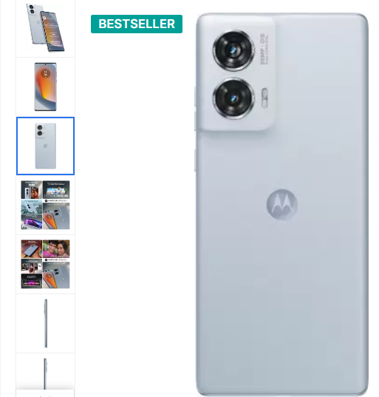

Footer

The footer is located at the bottom of every page, not just the Home Page. This block of miscellaneous links is useful in sorting relevant pages for the customer that may not logically sort anywhere else.



The organizational scheme of the footer can be divided into the following sections:

• About: Contact Us, About Us, Careers, Flipkart Stories, Press, Corporate Information.

• GROUP COMPANIES: Myntra, Cleartrip, Shopsy.

• HELP: Payments, Shipping, Cancellation & Returns, FAQ, Report Infringement.

• CONSUMER POLICY: Cancellation & Returns, Terms of Use, Security, Privacy, Sitemap, Grievance Redressal, EPR Compliance.

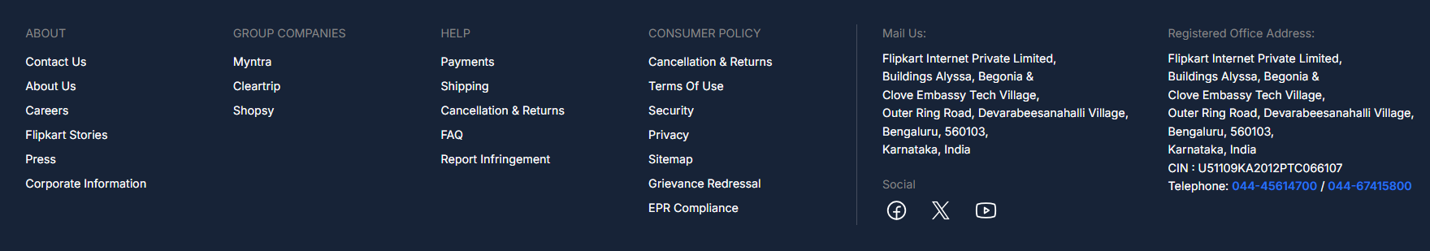

Product pages

The Flipkart default product page will follow the structural format seen below.

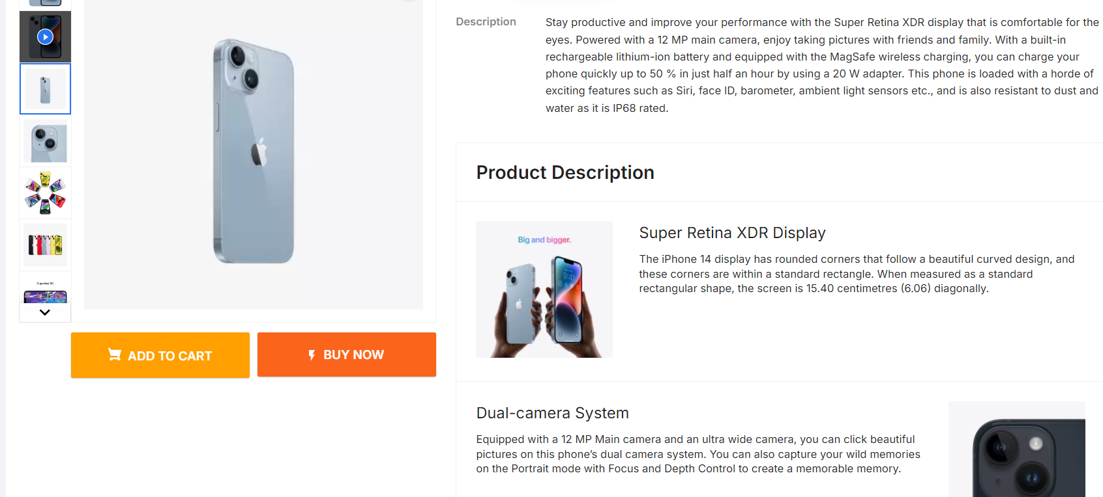

The product page can be divided into the following sections:



* **Product image:** The product image can be displayed under the title on the left side, along with alternate views of the product underneath it in smaller box.
* **Product details:** The product code, availability, and price are displayed just right to the product image.
* **Cart:** The customer can select a quantity and add the product to their cart, wish list, or compare.
* **Buy Now:** The customer can click on the buy now tab and it will redirect on checkout page.
* **Rating/Sharing:** Underneath the cart can rate the product and/or share the product on different social media websites.
* **Description:** An area underneath the main product information to provide a detailed description of the product.
* **Review:** An area for the customer to write a review on the product.

Category product listings

Category product listings enable customers to browse products similar to other

products within the same category. This is especially helpful for customers looking to

compare products, a feature that will be explained under Categories.

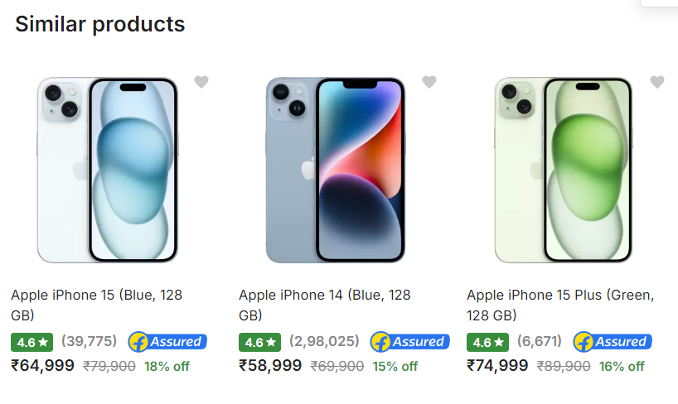

Similar products provide customer with alternatives the meet their needs.



Product compare:

The "Add to Compare" feature in the product section allows the customer to compare the different specifications, features, and price of a number of products s/he might be interested in.

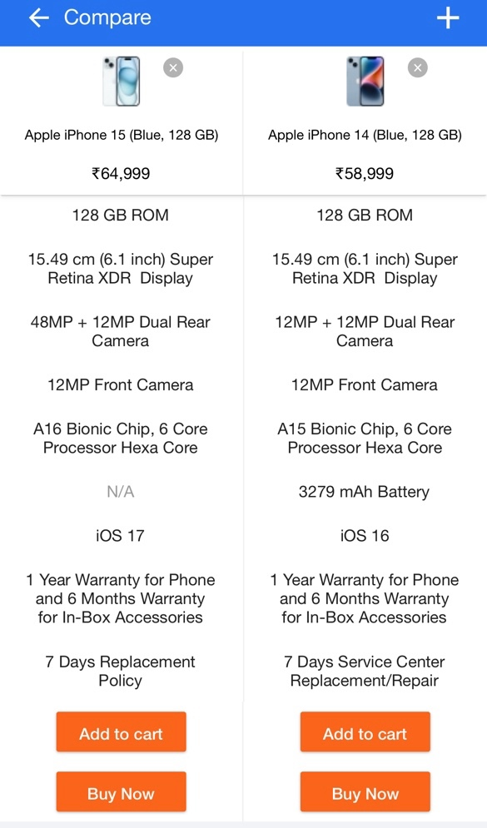

The customer is given the option to add one of the compared products to the cart if they want to.

Shopping Cart page

Once a customer adds a product to the cart, they can access the shopping cart in the header under "Shopping Cart".

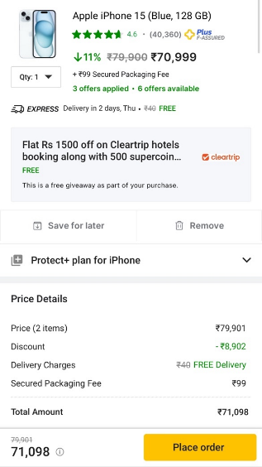

The shopping cart gives an overview of the product selected by including the categories "Image", "Product Name", "Model", "Quantity", "Unit Price", and "Total". The customer has an option to add a coupon code or gift voucher, or estimate shipping & taxes, before heading to the place order.

Creating an account

Before a customer can continue checking out a product from the shopping cart, the customer needs to create or log into their account.

There are a few ways a customer can make an account:

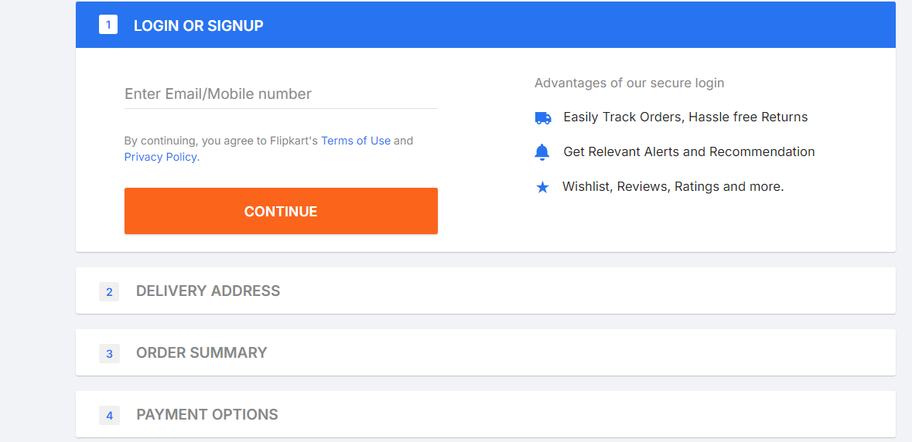

Checkout process allows the user to make an account or Login before continuing with payment. Delivery Address, order summary and payment asks for the same personal details, except that it asks for the user to create a password for their account. After that customer may continue with the checkout process.

Checkout

Once a product has been added to the cart, the customer can continue to the checkout to make their product purchase. Customer checkout using Flipkart is a simple process that can be completed in few steps.

* **Step 1: Checkout options**

The customer can log into or register their account for place order.

* **Step 2: Delivery Address**

Personal details including "First Name", "Last Name", "E-mail", and "Telephone" are filled into a form. It also requires the customer's address details.

* **Step 3: Order Summary**

Product quantity and product details are mention



* **Step 4: Payment Option**

The customer selects their method of payment here.

* **Step 5: Confirm order**

In this last step, the customer will see an overview of their purchase; including the product description, quantity, and price (with tax & shipping).